1. Open the Registry Editor (Open the “Run” dialog box, type regedit and hit “Enter”).
2. Navigate to the following Registry key:
HKEY_LOCAL_MACHINE\SYSTEM\CurrentControlSet\Control\
3. Create a New Key named as StorageDevicePolicies. To do this right-click on Control, and click on New->Key and name it as StorageDevicePolicies.
4. Now right-click on StorageDevicePolicies and create a New->DWORD (32-bit) Value and name it as WriteProtect.
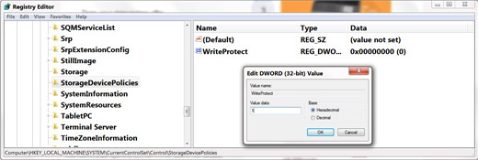

5. Double-click on WriteProtect and set the Value data to 1.
Now the right-protection for USB drives is enabled on your computer (no restart required) and thus it would not be possible for anyone or any program to add/delete the contents from your USB flash drive. Any attempt to copy or download the files onto the USB drive will result in the following error message being displayed.
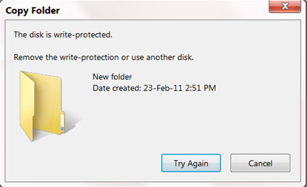

To revert and remove the write-protection, all you need to do is just change the Value data for WriteProtect (Step-5) from 1 back to 0. Now write access to all the USB devices is re-enabled.
Sometimes it may seem difficult to remember and follow the above mentioned steps each time you want to enable/disable the write protection. Hence as an alternative way, there are many tools available to automatically enable/disable the write-protection feature. One of my favorite tool is USB Write Protect by Naresh Manadhar. Using this tool you can limit write access to your USB drives with just a click of a button. You can download this tool from the following link:
USBWriteProtect

